

Relay Race Information

Please read along with Participant Instructions
Teams must be made up of 2 or 3 people and can be same sexed or mixed. Relay participants will run alongside the half marathon participants and can be identified by their white bib number.
Team captains will receive all the team bibs in the post. If your bibs do not arrive please arrange to collect on Saturday 23 August or on race day. See participant instructions for details of where you can collect.
You may change the running order of your team without informing the event. However, you must ensure that the person running the last leg is wearing the chipped bib. This is the bib with the chip above the number as shown below:



Leg 1: gather in the appropriate start pen determined by your team’s predicted finish time
Leg 2: meet in Start Hub relay leg 2 muster station at 10:30 to be led to changeover area
Leg 3: meet in the start hub at the leg 3 muster station at 10:25 to be led to your bus. The relay bus will leave from Glenarm Road at 10:30 sharp, please do not be late, the bus will not wait for you.
N.B. Please note that Leg 2 and Leg 3 Muster stations are at separate locations. See map below.
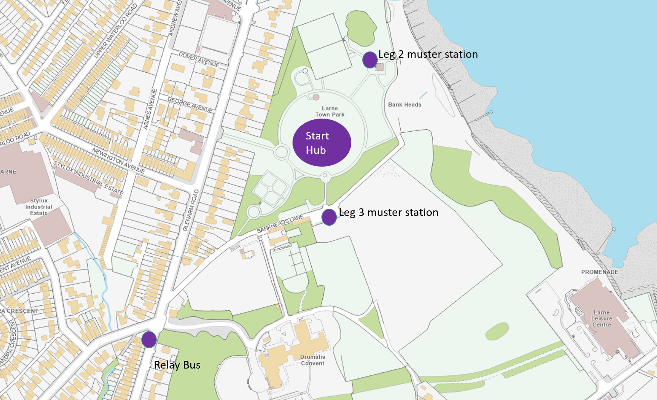
Relay muster stations in start hub

Relay Legs

Leg 1: ~7km
Leg 1 participants will gather in the appropriate start pen in the Start Hub determined by their team’s predicted finish time. Please be in the correct start pen before 10:30, the race will start at 11:00 sharp.
Leg 1 will cross the start line, run the town section of the route, and pass through the start line again on the way towards Ballygally. The changeover area is in the first lay-by on the A2 Coast Road. Here they will run into the layby, through the flags and touch the hand of their teammate to send them on their way.
Leg 1 runners can then make their way to the race finish hub via Larne Town Parks and Promenade, to avoid walking on the race route. You will be able to collect any items left in the bag drop on your way.
Please take care not to obstruct other relay runners changing over or other half marathon runners on the course as you make your way to the finish hub.

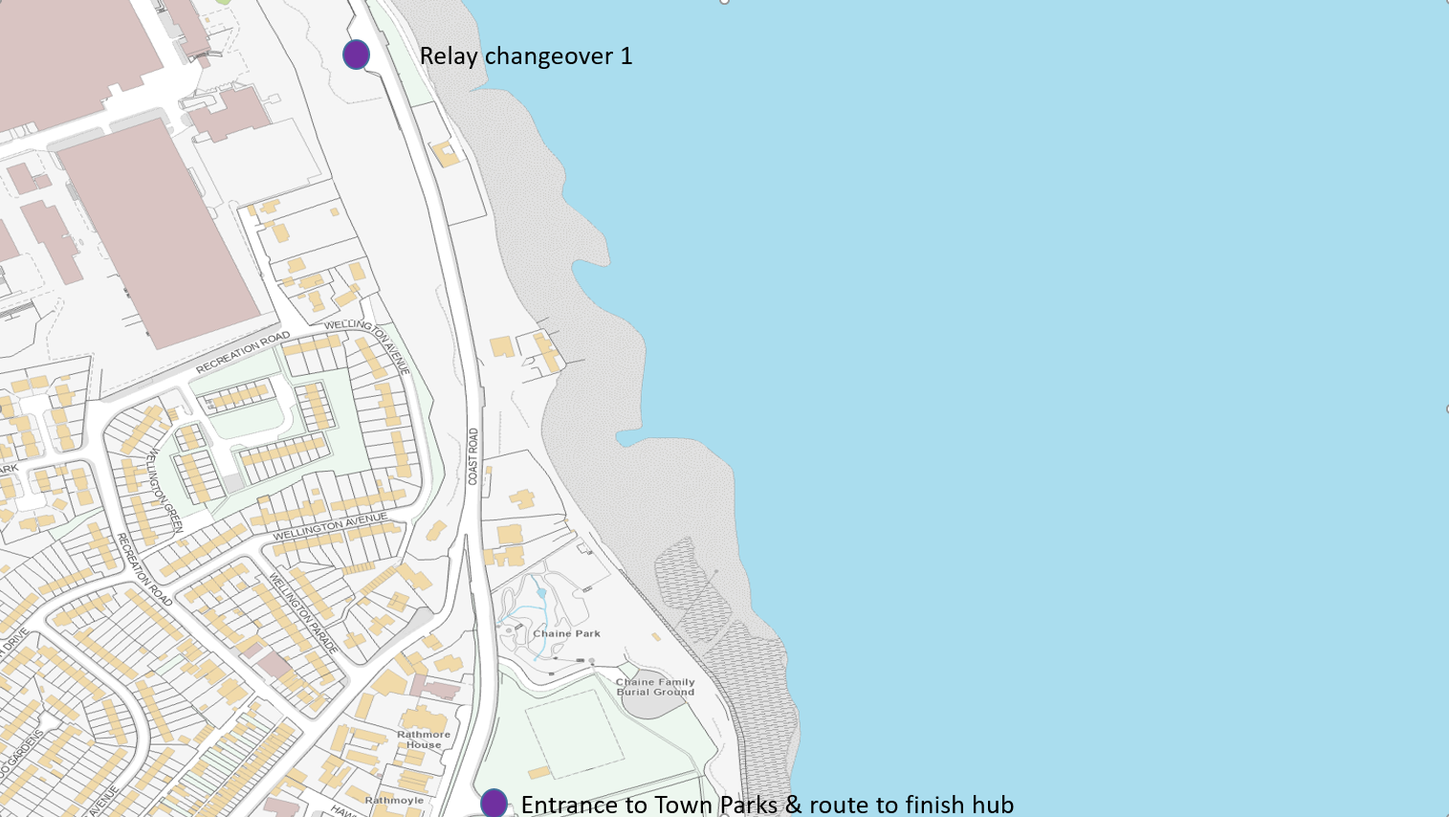
Relay changeover 1

Leg 2: ~7Km
Participants running leg 2 of the relay will gather in the Start Hub in the relay area. At 10:30 they will be guided from here to their starting position in the lay-by on foot. There will be port-a-loo facilities in the lay-by.
Leg 2 participants run from the lay-by to Cairncastle Road in Ballygally village, approximately 7Km. At the relay exchange area participants should run through the flags to touch the hand their teammate. They can then alight the relay bus and be transported to the finish hub.
The bus will leave Ballygally with relay runners at 12:30. Any relay runners reaching the changeover area after 12:30 will be transported to the finish area by the race sweeper bus.
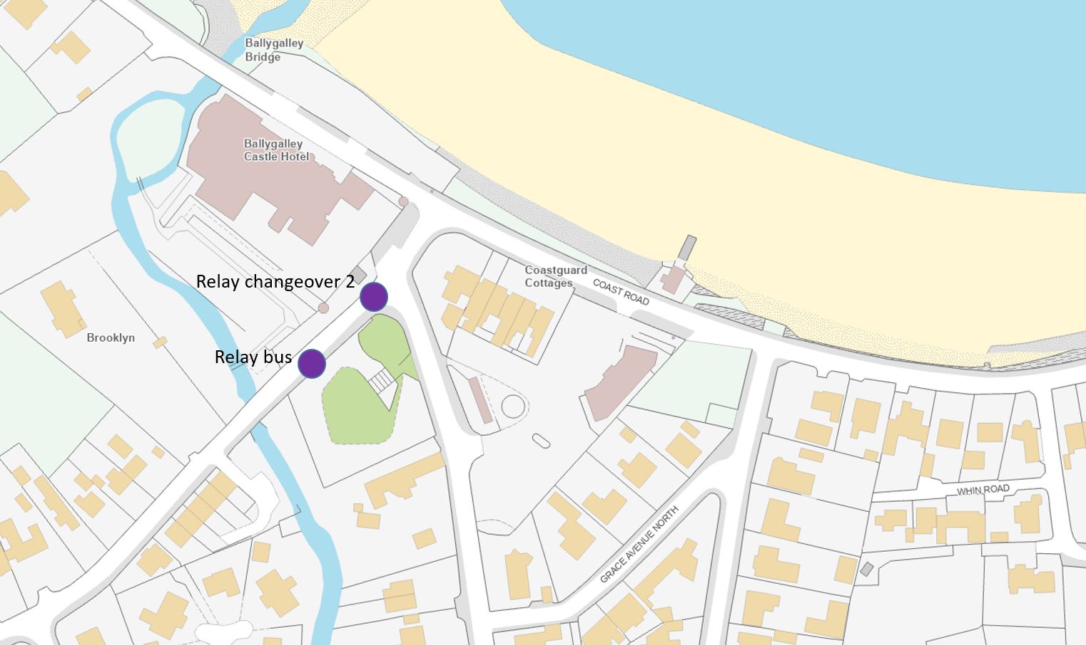
Relay changeover 2

Leg 3: ~7Km
Leg 3 relay runners must gather in the Start Hub in the relay area. At 10:25 they will be directed to the Relay bus that will transport them to Ballygally and the changeover area. The bus will leave at 10:30 sharp, please do not be late, the bus will not wait for you.
There are public toilet facilities in Ballygally and Martello Jazz Band will be entertaining spectators and participants on the sea front during the race.
Leg 3 participants will touch the hand of their teammate at Cairncastle Road and run from there along the Coast Road to the finish line on Chaine Memorial Road, ~7.9Km.
Once over the line, all relay participants should keep moving and make their way to the Finish Hub in Sandy Bay Playing Fields to meet the rest of their team.
The leg 3 runner will collect a medal for themselves once over the line. In the Finish Hub please proceed to the T-shirt collection point for relay runners. There you will collect a bag with medals and t-shirts for all your team. You will have to give your team name to collect your bag.
Note: only the leg 3 runner can collect the team t-shirt bag.

2-Person Teams
Any two-person relay team requires one team member to run two legs, either 1&2 or 2&3. It is not possible to run leg 1 and then leg 3.

Please follow the instructions of the race marshals at all times. They are there for your safety.

Please be advised that record numbers are attending Antrim Coast Half Marathon this year. You are therefore advised to plan to arrive early and to car share if possible.

